Bishajit Lodh

Challenge 1

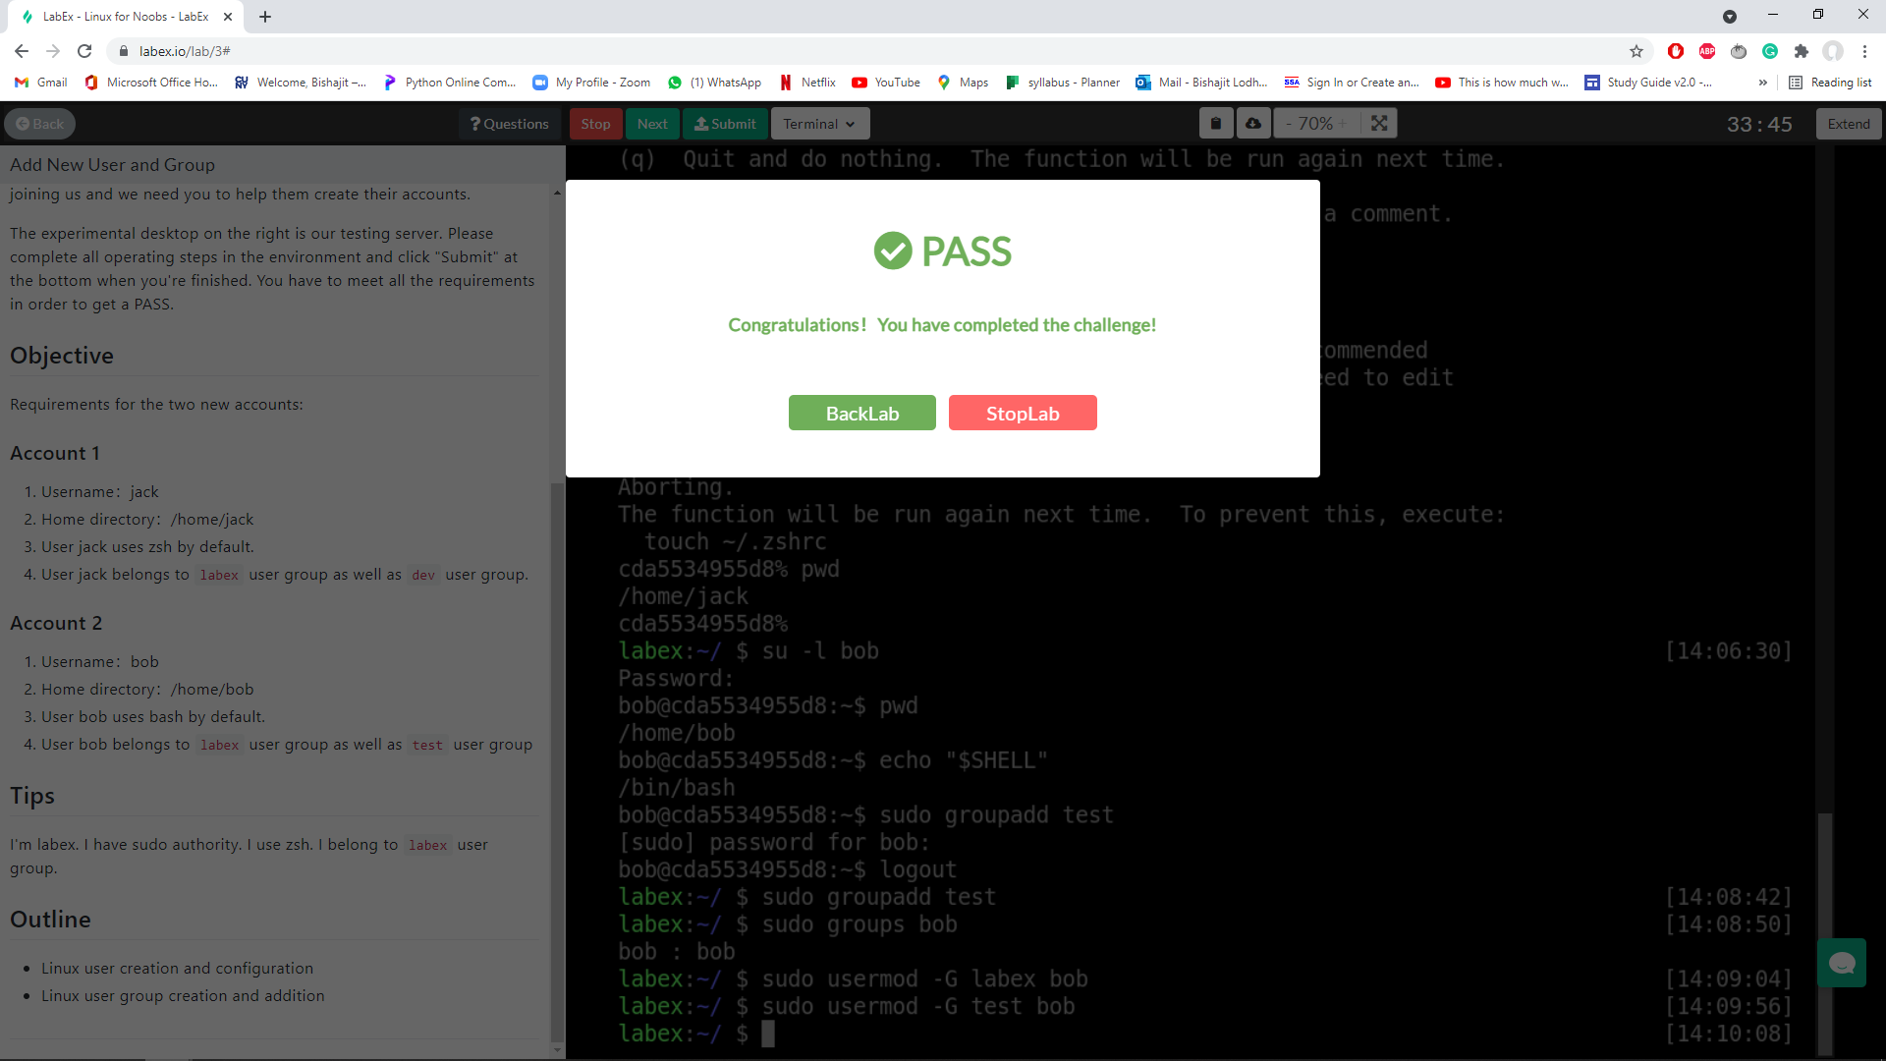

1. First I created the user using sudo adduser Jack in the home directory of the root user labex and also created a password for it. Using su -l jack, I got into the jack user and pressed pwd to make sure I created it in the home directory.
2. To change the default shell for the jack user, I needed internet help so I used this site

<https://www.lostsaloon.com/technology/how-to-change-the-default-shell-for-an-user-in-linux/>

Using the site I learned how to change the default shell for a user which for which was by using the command chsh -s /bin/bash jack while in the jack user. I made sure my shell changed by using the command echo "$SHELL"

I found this echo command from

<https://www.cyberciti.biz/tips/how-do-i-find-out-what-shell-im-using.html>

1. I knew how to add a group from the lab. So I did this pressing the command sudo usermod -G labex jack. I tried the same command but I found dev isn't a group. I didn’t know how to create a user group dev so I searched it and this is it what google gave me <https://www.techrepublic.com/article/how-to-create-users-and-groups-in-linux-from-the-command-line/>

Using that site I learned how to create a group which in my case would be by using the command sudo groupadd dev.

1. I did pretty much the same thing for the second account of bob but with different names when it comes to creating user name and it had a different group that needed to be made for bob to go into. Also bob had a different shell than jack which was bash.

Challenge 2

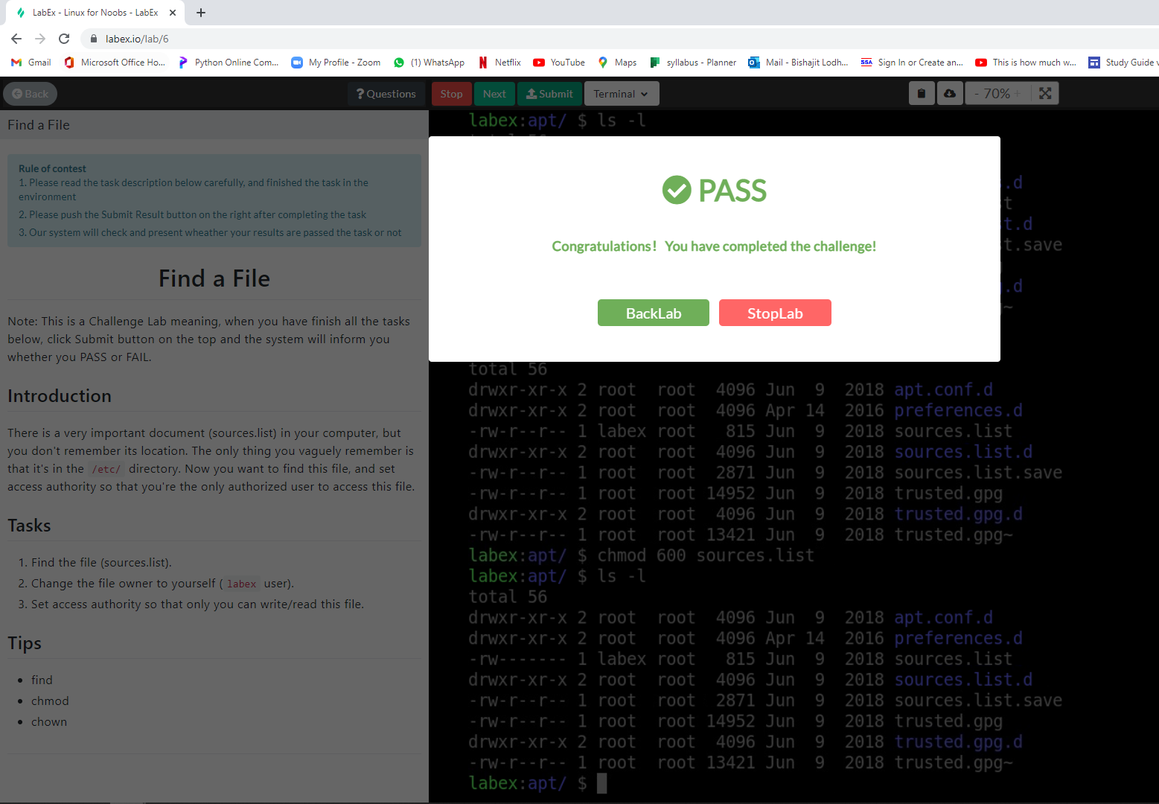

<https://www.plesk.com/blog/various/find-files-in-linux-via-command-line/>

<https://askubuntu.com/questions/333710/how-to-find-all-files-with-the-same-extension-within-a-directory>

<https://phoenixnap.com/kb/linux-chown-command-with-examples>

The tips were very helpful in doing this challenge or tasks.

1. To do the first task,I tried to find . -name sources.list which didnht work. Then I read the prompt more carefully and leaned the sources.list was in the /etc/ directory. So then I realised if I have to go to the directory where sources.list is located. In order to do that I use command cd /etc And I forgot the command to search through a directory to isolate specific folder that may end with “.list”. This website

<https://askubuntu.com/questions/333710/how-to-find-all-files-with-the-same-extension-within-a-directory>

Helped me realise use the command find /etc -type f -name "*.list". I found the sources.list in the apt directory which I immediately went to by using the command cd apt. Just to make sure I was using the correct command to find the sources.list file, I double checked this website

<https://www.plesk.com/blog/various/find-files-in-linux-via-command-line/>

And then used the command find . -name sources.list to find the file as the task wanted.

1. To change the labex user I wasnt sure about the full command so this site helped me confirm my assumption on what the command is to change a file’s owner .[https://www.plesk.com/blog/various/find-files-in-linux-via-command-line](https://www.plesk.com/blog/various/find-files-in-linux-via-command-line/)

After using command the website told me to use, it failed. Then I remembered I have to sudo to change the owner.I changed the file’s owner by using the command sudo chown labex sources.list. I made sure it was changed by using the command ls -l

1. I remembered from class how to do this but I used google to affirm my assumptions on how to set access so only I(owner of the file) can write/read the file.

<https://www.pluralsight.com/blog/it-ops/linux-file-permissions>

After affirming my assumption I used the command chmod 600 sources.list. I made sure it was correct by using the command ls -l to see if permissions changed.

Challenge 3

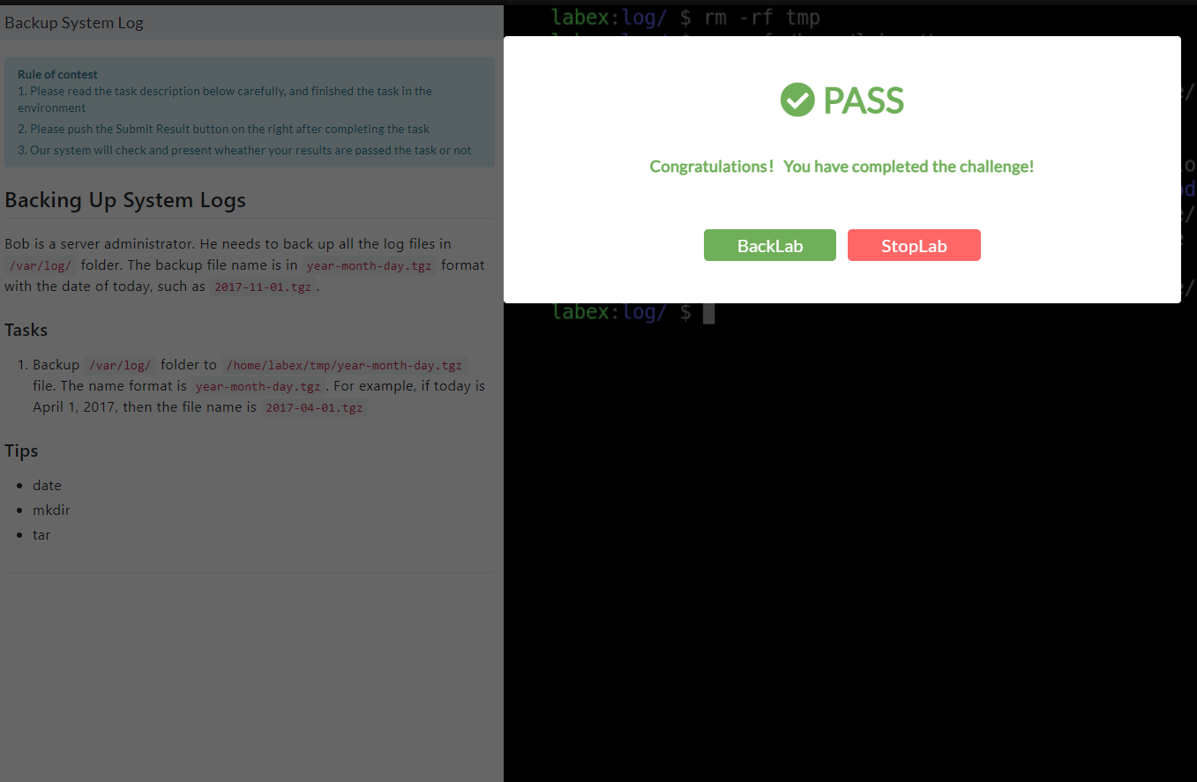

1. First I made the directory then I used tar function I found in the internet

[https://www.howtogeek.com/248780/how-to-compress-and-extract-files-using-the-tar-commanon-linux/](https://www.howtogeek.com/248780/how-to-compress-and-extract-files-using-the-tar-command-on-linux/)

To do that i did this code

mkdir /home/labex/tmp; sudo tar -cf /home/labex/tmp/$(date +%F).tgz *

Challenge 4

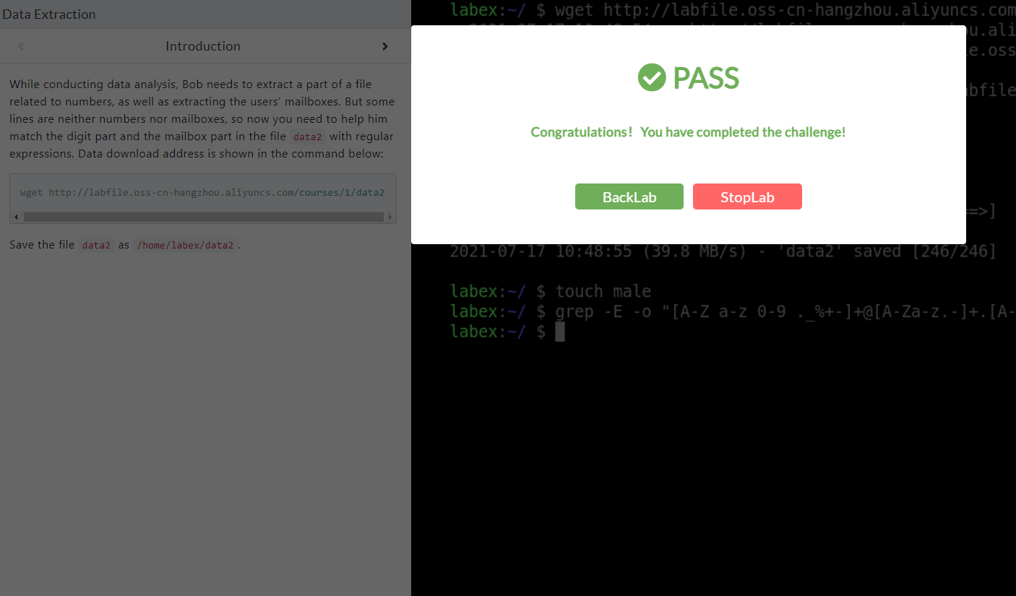

What I used for this <https://likegeeks.com/regex-tutorial-linux/>

1. WHat I did was follow the format of an email using a regular expression.To this in entered the code they gave me. wget http://labfile.oss-cn-hangzhou.aliyuncs.com/courses/1/data2

\

2)Then I made a male folder as the problem instruct

3) After that I used grep -E -o "[A-Z a-z 0-9 ._%+-]+@[A-Za-z.-]+.[A-Z a-z]{2,6}" data2 > mail